DTools

User manual

Matjaž Cerkvenik
2015

Contents
1. Introduction 4
2. Installation 5
2.1 Prerequirements 5
2.2 Installation 5
2.3 Start DTools 5
2.4 Stop 6
2.5 Update 6
2.6 Manual upgrade 7
2.7 Uninstall 7
3. Administration 8
3.1 Users 8
3.2 Application configuration 8
3.3 Configuring Tomcat HTTP port 8
4. Navigation in DTools 10
4.1 Toolbar 10
4.2 Breadcumb 10
5. Home view 12
6. Network view 13
6.1 Node status 13
6.2 Adding new nodes 14
6.3 Auto discovery of nodes 14
6.4 Node details view 15
6.5 Monitoring services 16
7. SSH clients 18
8. FTP clients 20
9. SNMP Simulator 21
9.1 SNMP Manager 21
9.2 SNMP Agents 22
10. Trap monitor / Alarm monitor 23
11. Javascript trap processing API 24
11.1 Trap parameters 24
11.2 Trap rules 26
12. Troubleshooting 28
12.1 JRE_HOME environment variable is not defined correctly 28

Introduction
DTools is highly customizable tool for developers who need SSH connections to servers to execute commands. The commands can be saved and reused by single click, without re-typing them in terminal window. Regular developers also need FTP to transfer files to/from the server. The commonly used transfers can be saved and revoked by single click (eg. download log files or upload configuration files).

On the other side DTools is advanced monitoring tool and fault management system. It provides monitoring of services and faults through the SNMP protocol.
DTools enables access to monitored nodes via SSH, FTP of SNMP protocol.

DTools provides the following features:
- Home: show favorite servers, SSH and FTP clients and saved SSH sessions
- Network: add new server and view configured servers
- Network monitoring
- Auto discovery
- Nodes: add services and configure monitoring
- SSH: create SSH clients and save common commands
- FTP: create FTP clients and configure common files to download/upolad
- SNMP client: GET commands
- SNMP agent: send SNMP traps
- SNMP manager: receive SNMP traps
- Trap monitor: process SNMP traps with JavaScript
- Docker status
- Todo list: create custom todo notes with deadlines
- Notes: create simple notes

Installation

Prerequirements
Java 6 or higher is required to run DTools.
Java must be added to PATH.

Supported operating system: Linux, OS X and Windows, Raspbian.

Installation
DTools come as tar.gz package. Copy the package to custom directory. First unzip the package then untar.

Linux and OS X | Windows
$ gunzip DTools-x.y.z.tar.gz  $ tar -xvf DTools-x.y.z.tar  or shorter:  $ tar zxf DTools-x.y.z.tar.gz | Use cenventional tool for unziping

DTools-x.y.z directory is created containing all necessary files to run the application.

Start DTools
Start DTools server

Linux users: before starting make sure that all .sh files in bin directory have executable permissions:

$ chmod a+x *.sh

Linux and OS X | Windows
$ cd $DTOOLS_HOME$/bin  $ ./start.sh | Double click start.bat

Open web browser and point to url: http://localhost:8080/DTools

Stop
Stopping DTools server

Linux and OS X | Windows
$ cd $DTOOLS_HOME$/bin  $ ./stop.sh | Double click stop.bat

Update
 | Server must be stopped before running update!

Start updater application

Linux and OS X | Windows
$ cd $DTOOLS_HOME$/bin  $ ./update.sh | Double click update.bat

Updater checks installed version of DTools with version on server. If version on server is higher the user is prompted to continue with installation

[root@localhost bin]# ./update.sh
DTOOLS_HOME=/opt/DTools-0.3.0
Current version: 0.3.0
Last version: 1.2.3
Do you want to upgrade now? [y/n]:

To proceed with installation choose y, otherwise choose n to exit the updater.

Updater will undeploy installed DTools application, clean Apache Tomcat's work directory, backup documentation and configuration to repository and install new application and documentation. Config directory remains untouched.

If update application is run from command line, the following arguments could be used:

-h show help
-c check for last version on the server
-m md5 checksum of DTools.war
-d turn on debug mode
-r x.y.z restore selected version from repository
-s show repository

Manual upgrade
Download and unzip new version of DTools into custom directory. Copy config directory from old version to new version to preserve existing configuration files.

Uninstall
Server must be stopped before uninstalling!

Remove DTools-x.y.z directory.

Administration

Users
Currently DTools does not support multiple users. Default user is 'default'.
All user configuration data is stored in $DTOOLS_HOME$/config/users/default directory.

Application configuration
DTools application configuration data is stored in file:
$DTOOLS_HOME$/config/dtools.properties

The configuration includes the following parameters:

Parameter | Default value | Description
dtools.gui.css.theme | antracit | CSS styling
simplelogger.filename | dtools.log | Absolute or relative path of log file
simplelogger.level | INFO | Log level
simplelogger.maxBackupFiles | 2 | Maximum number of log files before they get overwritten.
simplelogger.maxFileSize | 1 | Maximum log file size in megabytes
simplelogger.verbose | TRUE | Print logger information to console
simplelogger.dateFormat | yyyy.MM.dd hh\:mm\:ss\:SSS | Date format in log files
simplelogger.append | TRUE | Append or overwrite log files
network.monitoring.ping.interval | 60 | Ping interval in network monitoring
network.monitoring.ping.pool.size | 10 | Number of consecutive ping processes
network.autodiscovery.thread.pool.size | 10 | Number of consecutive threads for autodiscovery
snmp.receiver.queue.size | 100 | Trap receiver buffer size
snmp.rules.file | /config/users/default/snmp/manager/rules/trap-rules-default.js | Default rules file for processing traps. Path is relative to $DTOOLS_HOME$ directory.

Configuring Tomcat HTTP port
By default Apache Tomcat server is running on port 8080. Port must be specified in URL to access DTools web portal:

http://localhost:8080/DTools

Apache Tomcat's listening port can be changed in file

$DTOOLS_HOME/server/apache-tomcat-7.0.57/conf/server.xml

Inside element <Connector> set the custom value of port attribute. Example:

<Connector port="7070" protocol="HTTP/1.1"
connectionTimeout="20000"
redirectPort="8443" />

Restart Apache Tomcat server.

DTools web portal is now reachable on port 7070:

http://localhost:7070/DTools

Navigation in DTools

Toolbar
All views in DTools contain toolbar to switch between various functionalities.

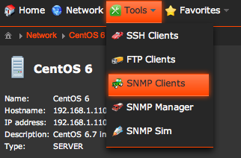

Toolbar provides access to:
- Home view
- Network view
- Tools
  - SSH clients
  - FTP clients
  - SNMP clients
  - SNMP manager
  - SNMP simulator
- Favorites
  - TODOs
  - Notes
  - About Dtools
  - Settings
  - Link to Google

Breadcumb
Breadcumb is navigation pane right below toolbar. It shows hierarchy of views.

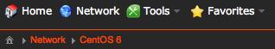

Example shows that the user is viewing Home -> Network -> Node view (CentOS 6).

Home view
Home view contains quick links to your favorite tools – nodes, SSH clients, FTP clients.
The line at the top shows current system user, Dtools username (currently only default) and IP address of local host.

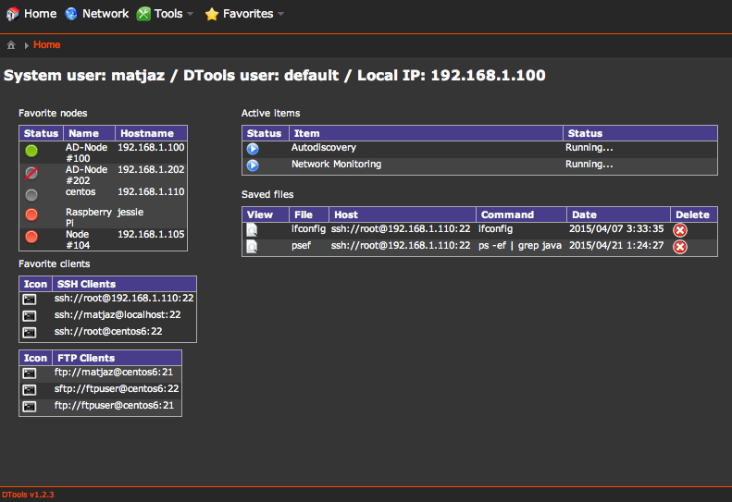

Favorite nodes shows nodes marked as favorites.

Favorite clients show clients marked as favorite.

Active items table shows running processes such as:
- autodiscovery
- monitoring

Saved files table contains saved responses from SSH clients.

Network view
Network view contains list of network elements (nodes) and provides quick overview of node's statuses (see chapter 6.1).
New nodes can be added manually (see chapter 6.2) or automatically by auto discovery feature (see chapter 6.3).
Monitoring trigger starts monitoring process of all nodes in the list. For each node all services are checked if they are reachable according to configured ping type (see chapter 6.5).

// TODO replace picture
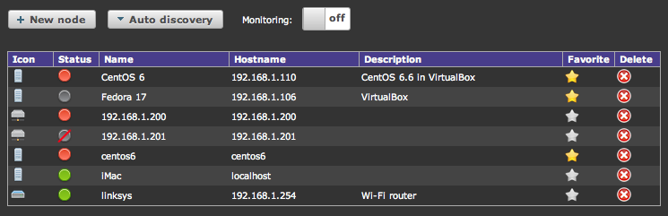

The nodes table shows:
- node icon
- connectivity status
- node name
- hostname or IP address
- description
- favorite flag (favorite nodes appear in home view)
- delete node button

By clicking on the icon, name or hostname, the node details view is opened.

Network Location

By clicking on 'Create location' new location or group of nodes can be created.
New nodes must be added in each location (even if it already exists in another location – that is different node).
Nodes can be grouped in locations by custom criteria (eg. My Home Network or Western Region or Cisco switches...)
Network location is deleted by clicking on 'Delete Location' button.

Node status
Status icons provide overview about the accessibility of the nodes. By clicking on the status icon, the ICMP service of the node is checked (ICMP ping) and the status icon is changed accordingly.

Icon | Description
 | Unknown status  The status of node has not been determined yet.
 | Node not monitored  The node is not monitored or has no services defined (nothing can be monitored).
 | Critical  ICMP ping failed, no connection to node
 | Critical with question mark  ICMP ping failed because hostname cannot be resolved to IP address
 | Normal  ICMP ping successful, node is reachable
 | Major  - not implemented -
 | Warning  HTTP ping returns error code other than 200
 | Blue  - not implemented -

Hover a mouse pointer over the status icon to see ICMP ping info:
- errorCode (eC)
- errorMessage (eM)
- errorDescription (eD)
- startTime (sT)
- endTime (eT)
- deltaTime (dT)

Adding new nodes
Click on 'New node' button to add new node. A dialog window opens. Enter the custom name of node (must be unique), hostname or IP address of node, add description (optional) and select type of node.

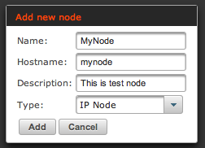

Remark: Currently the type of node only determines the node's icon.

New node should appear in the list of nodes. By default all new nodes get ICMP service automatically added.

Auto discovery of nodes
Auto discovery feature sends ICMP ping to all IP addresses in selected range. If ICMP ping is successful, the node is automatically added to the nodes list.

Remark: Only one autodiscovery process can be run at once.

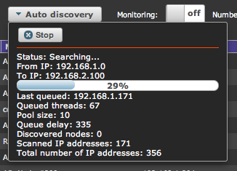

Autodiscovery can be stopped by clicking on 'Stop' button. Queued pings will be terminated, but pings in pool will be executed anyway.

Autodiscovery information:
- From IP – starting IP address
- To IP – ending IP address
- Progress bar (updated every 3 seconds)
- Last queued – IP address of last queued ping
- Queued threads – number of pings in queue
- Pool size – max number of pings waiting for reply
- Queue delay – delay between new ping (delay = 5 * queued threads); more pings queued, the larger the delay
- Discovered nodes – number of new auto discovered nodes
- Scanned IP addresses – number of pings sent
- Total number of IP addresses – total number of IP addresses in selected range

Node details view
Node details view provides detailed information about the node, lists available services and clients.

The first part shows information about the node:
- node name
- hostname (or IP address)
- IP address (if it can be resolved from hostname)
- description
- type of node (icon)

The value of each field can be changed by clicking on that value.

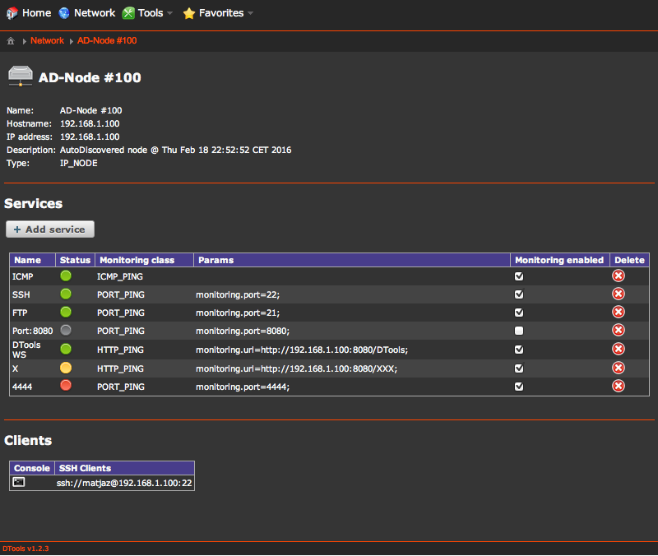

Services table shows services that are configured on selected node. Each service can be monitored by specific ping (ICMP, PORT or HTTP). The table shows the following data:
- name of service
- status icon shows availability of service
- monitoring class – type of ping
- service parameters
- monitoring enabled – the service is monitored by periodic ping

Last part shows SSH of FTP of SNMP clients on selected node.

Monitoring services
By default when node is created the ICMP service is automatically added. New services can be added by clicking on the 'Add service' button. A dialog window opens.

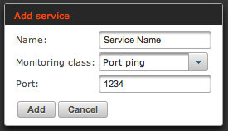

Enter the required data depending on selected monitoring class:
- service name
- select monitoring class (see table below)
- additional monitoring parameters (see below)

The services can be monitored with the following monitoring classes:

Monitoring class | Parameters | Description
No monitoring | - | Service is not monitored
ICMP ping | - | Send ICMP ping to node. If ping is successful the status icon is Normal; if ping fails, the status icon is Critical.  ICMP service is also checked from the network view when clicked on status icon.
Port ping | port | Try to establish connection on selected port. If connection is successful, the service is running and the status icon is Normal. If no service is listening on selected port, the connection cannot be established and the status icon is Critical.
HTTP ping | url | Try to connect to selected url and retrieve HTTP response code. If returend code is 200 the URL is reachable and the status icon is Normal; if returned error code is other than 200 the status icon is Warning; if timeout occurs the status is Critical.
SNMP ping | - | - not implemented yet -

By clicking on the status icon the selected ping type is sent to this node to check service accessibility.

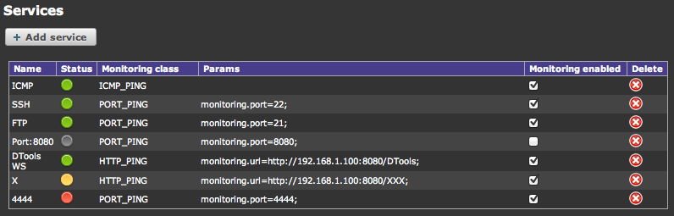

Services can be deleted by clicking on delete icon.

SSH clients
SSH Clients view let's you manage ssh connections and execute simple commands on remote devices.

Remark: Only simple commands can be executed with ssh clients. Commands that provide continuous display (eg. ping, tail, top...) are not supported.

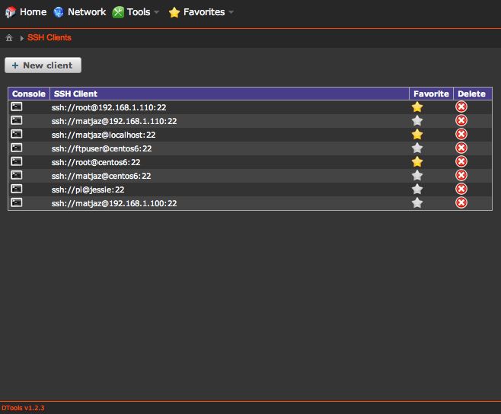

Add new SSH client by clicking on 'New client' button. Insert hostname, port, username and password in the dialog box. New client appears in the table.

Client can be opened by clicking on console icon or on the link.

Clients marked as favorite will be displayed in home view.

Delete button deletes the client.

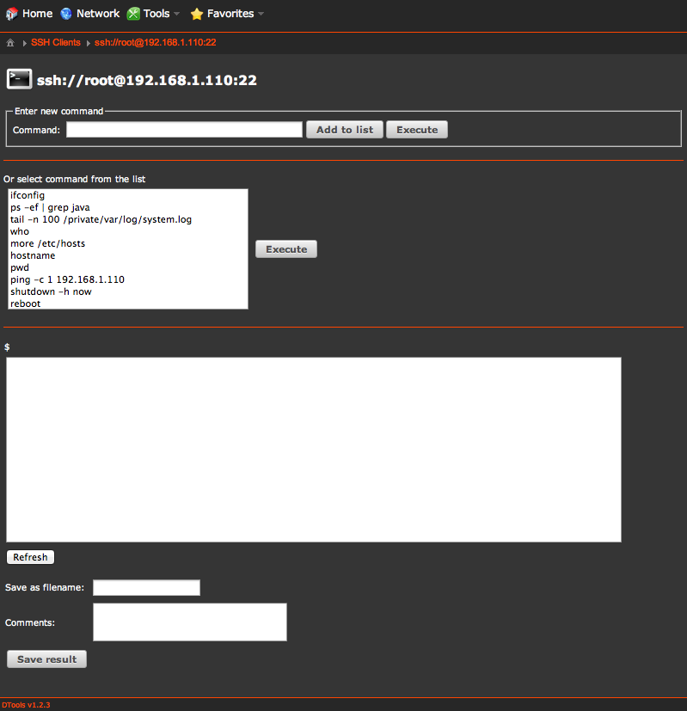

Commands can be saved to the list, so it's not needed to retype the same commands every time.

FTP clients
FTP Clients view is used to manage ftp/sftp connections and configure commonly used transfers of files (upload/download).

SNMP Simulator
SNMP simulator can simulate agents and managers.

Managers actively listen for SNMP notifications (traps) and can sent SNMP requests (GET, SET, WALK) to the agents.

Agents listen for requests from manager.

Custom MIB tables can be created.

Traps can be created with custom varbinds. Many traps can be added to scenario (list of traps). By selecting 'Start' button all traps from the table are sent to selected manager in defined interval. In such way a sequence of traps can simulate behaviour of real equipment.

SNMP Manager
SNMP manager receives traps. The configuration of manager includes:
- changing listening IP address and port where traps will be received
- changing the name of manager

The 'Active' trigger starts/stops trap receiver.

Manager provides overview of recived traps in two views:
- raw traps (plain text, varbinds)
- Trap monitor

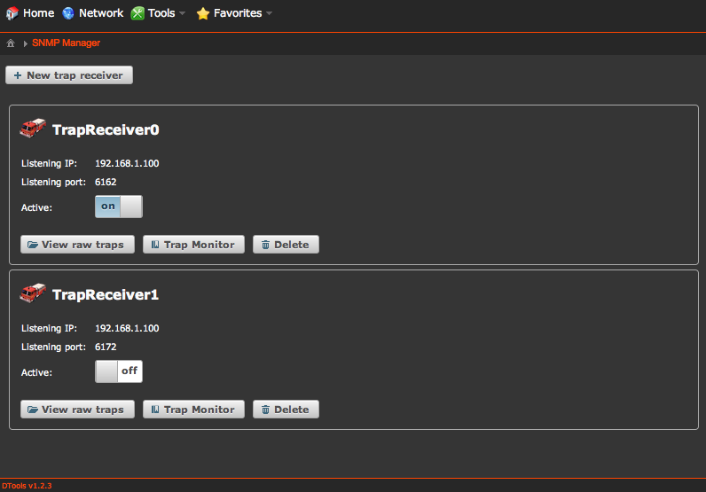

New managers can be added by clicking on the 'New trap receiver' button.

Manager is deleted by clicking on 'Delete' button.

SNMP Agents
kjashd

Trap monitor / Alarm monitor
sdfgsd

Javascript trap processing API
Javascript trap API is used in post-processing of received trap notifications. Rules for post-processing are written in javascript file.

In dtools.properties set the rules file:
snmp.rules.file=config/users/default/snmp/trap-rules.js

The rules file must comply with JavaScript syntax and must contain a function processTrap(trap) which processes the trap data. The function is called on every received trap. The function must return an object trap.

Trap parameters
Input argument of processTrap(trap) method is trap object, which provides access to all parameters of the trap.
Variables marked with * are automatically set by trap receiver, before processing in javascript. All values can be changed in javascript processing.

int no *
Sequence number of trap.

String uid *
Unique ID of trap.

String trapReceiverName *
Name of SNMP manager that received the trap.

String peerAddress *
Sender address (format: IP/port)

String peerIp *
Sender IP address

String peerHostname *
Resolved hostname of sender. If hostname cannot be resolved, IP address is returned.

String nodeName
Name of node that sent the trap.

String trapName
Name of trap (as defined in MIB). It could be any custom name (eg. linkDown).

String name
Custom name of trap (eg. Link is down).

int severity
Severity level of trap. Severity could be any integer, but the following values are already used for coloring of traps:

Value | Enumeration | Color
0 | Undefined | No color
1 | Critical | Red
2 | Major | Orange
3 | Minor | Soft orange
4 | Warning | Yellow
5 | Clear | Green
6 | Informational | Blue
Remark: values comply with ITU-X.733 standard.

String sourceInfo
Information about the source of trap. Data can be composed of several varbinds.

long timestamp *
Time of trap reception in milliseconds.

String date *
Human readable representation of timestamp in format yyyy/MM/dd H:mm:ss

String group
Custom trap group (eg. Network, Equipment, Power supply...).

String location
Custom node location.

boolean isV1
True if trap is version 1.

boolean isV2C
True if trap is version v2c.

String snmpVersion
Version of trap (either v1 or v2c).

String community *
Trap community.

int genericTrap *
Generic trap identifier.

int specificTrap *
Specific trap identifier.

String enterpriseOid *
Enterprise OID of trap (v1 only).

String snmpTrapOid *
Snmp trap OID (v2c only).

int extDat1
Custom extended data. Nine such parameters exist (extDat1 - extDat9).

String customText
Custom text (comment, additional information...).

boolean ignore
If set to true the trap will be discarded.

Trap rules
Trap rules is a javascript file which must implement method processTrap. The method uses one input argument trap and it must return object trap at the end:

function processTrap(trap) {

// some code

return trap;

}

Here are a few examples how to use trap rules.

Set basic variables:

function processTrap(trap) {

// set node name and location
if (trap.peerIp == "192.168.1.110") {
trap.nodeName = "CentOS 6";
trap.location = "Private network";
} else {
trap.nodeName = "TestNode 1";
trap.location = "New York";
}

// ignore non-public traps
if (trap.community != "public") {
trap.ignore = true;
return trap;
}

// set custom text
trap.customText = "This trap was received at " + trap.date;

// return the trap
return trap;

}

Reading variable bindings:

function processTrap(trap) {

// check version of trap
if (trap.isV2C == true) {

if (trap.snmpTrapOid == "1.3.6.1.6.3.1.1.5.3") {
// LinkDown
trap.severity = 1;
trap.trapName = "linkDown";
trap.customText = trap.trapName;
trap.extDat1 = "ifAdminStatus=" + getValue(trap.varbinds, "1.3.6.1.2.1.2.2.1.7");
trap.extDat2 = "ifOperStatus=" + getValue(trap.varbinds, "1.3.6.1.2.1.2.2.1.8");
trap.customText += " " + trap.extDat1 + " " + trap.extDat2;
} else if (trap.snmpTrapOid == "1.3.6.1.6.3.1.1.5.4") {
// LinkUp
trap.severity = 5;
trap.trapName = "linkUp";
trap.customText = trap.trapName;
} else {
trap.severity = 6;
trap.trapName = "unknownTrap";
}

}

return trap;
}

// search varbinds for oid and return value
function getValue(varbinds, oid) {
for (var i = 0; i < varbinds.length; i++) {
if (varbinds[i].oid == oid) {
return varbinds[i].value;
}
}
for (var i = 0; i < varbinds.length; i++) {
if (varbinds[i].oid.startsWith(oid)) {
return varbinds[i].value;
}
}
return "";
}

Docker status

DTools can show the current status of Docker:
- containers
- services
- sworm nodes
- stacks
- configs
- volumes
- networks
- images
- info

Remark: Docker daemon must be running on the same host as DTools.

Troubleshooting

JRE_HOME environment variable is not defined correctly
When trying to start DTools on Windows by double clicking on start.bat file I get an error message:

Starting OpenMp3Player...
The JRE_HOME environment variable is not defined correctly
This environment variable is needed to run this program
Press any key to continue . . .

This error message means that path to Java (JRE or JDK) is not set.

Solution 1: Add path to JAVA_HOME in Environment variables:
- Right click on Computer icon
- Click Advanced system settings
- Click on Environment variables
- Create new user variable JAVA_HOME and set path to java directory as a value

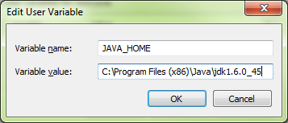
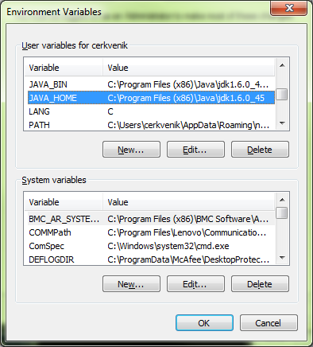

Solution 2: open start.bat with text editor and uncomment lines where JAVA_HOME and JRE_HOME are set (remove 'rem' at the beginning of the lines). Enter the path to JRE or JDK directory.

set "JAVA_HOME=C:\Program Files (x86)\Java\jdk1.6.0_45"
set "JRE_HOME=C:\Program Files (x86)\Java\jdk1.6.0_45"

